EXPERIMENT :01 (A)
Step1: Go to Start and open Control Panel.
Step2: Select System and Security > Windows Defender Firewall.
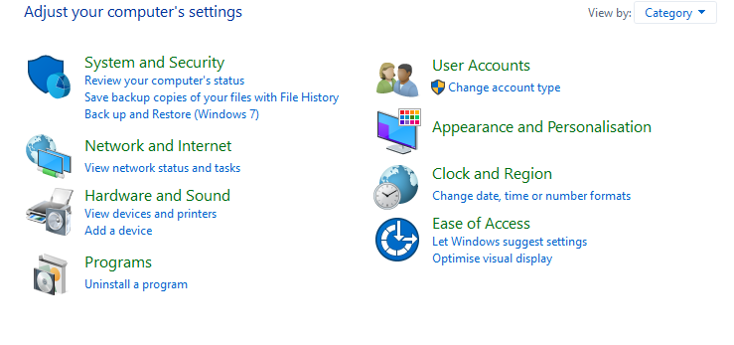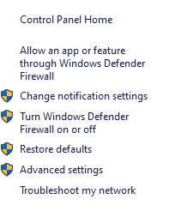
Step 3: Choose Turn Windows Firewall on or off.
Step 4: Choose Turn Windows Firewall on or off. Select Turn on Windows Firewall for domain, private and public network settings.
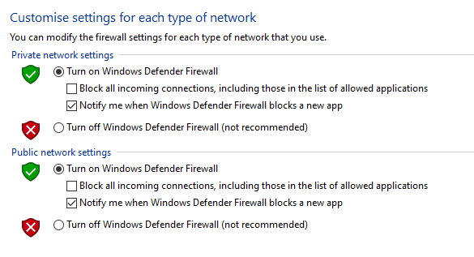

EXPERIMENT :02 (B)
Step 1: Go to browser, search for total 360 security antivirus software or any other antivirus software.
Step 2: Click on the download.
Step3: Open the Downloads folder and Double click the downloaded file and install it.
Step 4: Click on star > go to Full Check and Check Now.

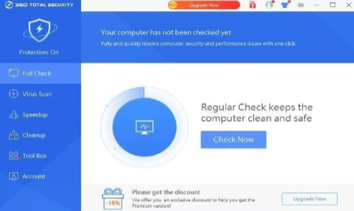

EXPERIMENT :03 (c)
Step 1: Go to browser and search for antispyware blaster and Select Download SpywareBlaster6.0
Step 2 : Select downloads and click on spyware Blaster.
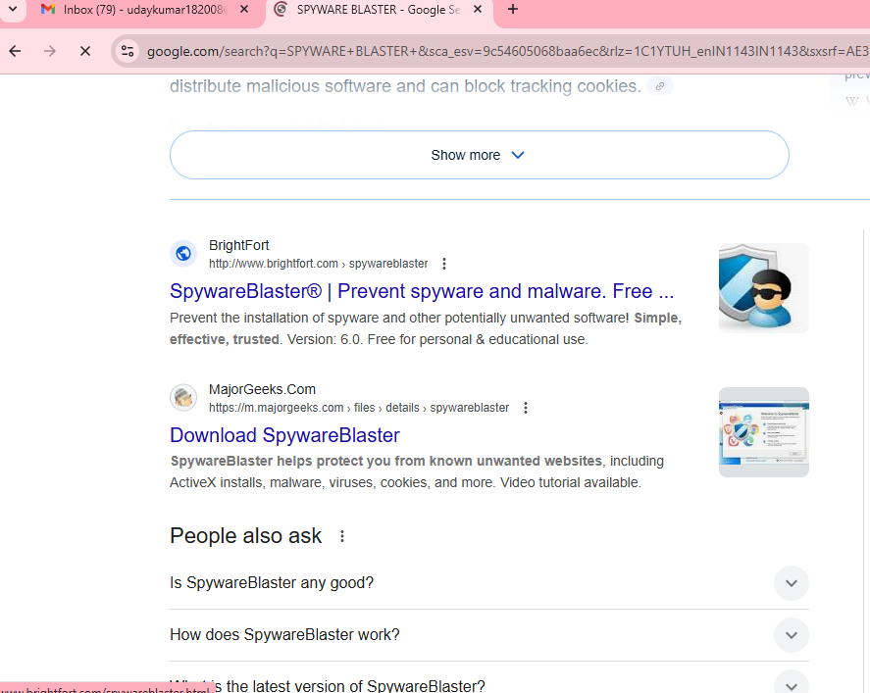
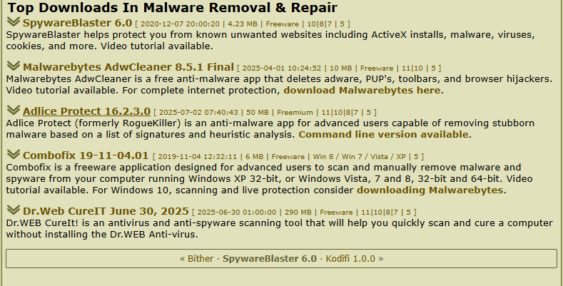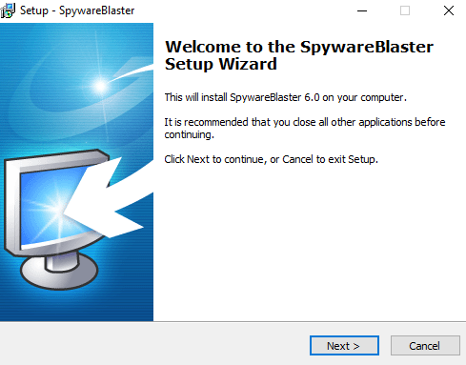
Step3: Open the spyware blaster setup6.0 from the downloads and install it.
Step4: Double-click on setup file > Agree to agreement > Browse the location > click next > Install.
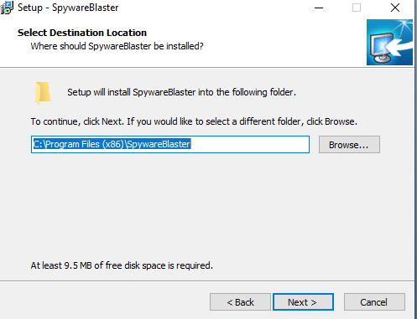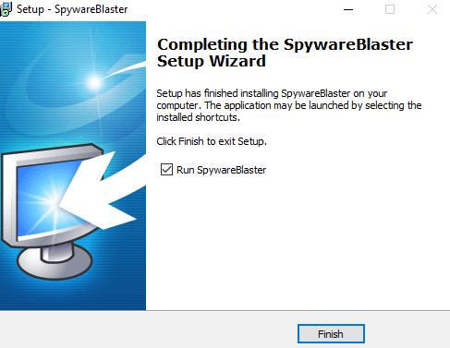
Step6: Open the application > click next > select automatic updating and click next.
Step7: Select the browser you to protect > select activate protection.
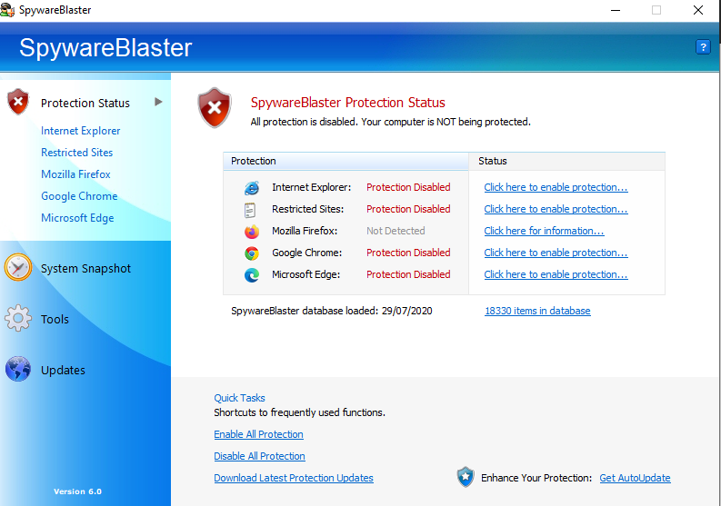
EXPERIMENT :04 (D)
Steps to setup Password protection
Step1:Go to Start and open Control Panel.
Step2: Select User Accounts > click Change Account Type.
Steps3: Double click on User account > click on create password.
Step4:Enter new password and confirm the password > click create password.
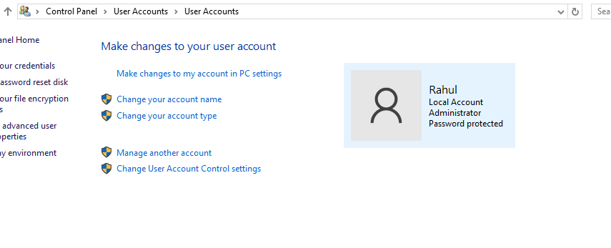
Experiment 1.5
Website certificate check:
Step 01 : go to firefox and search any website
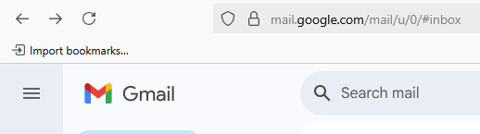

Step 02 : click lock icon on left side top corner and click connection secure
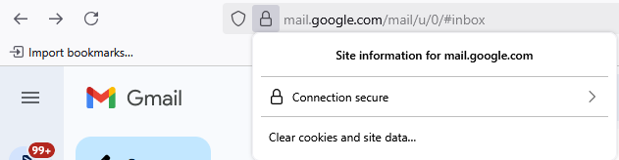
Step 03 : click more information
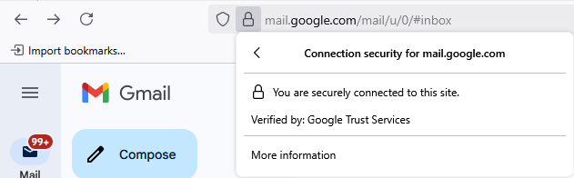

Step 04 : click view certificate
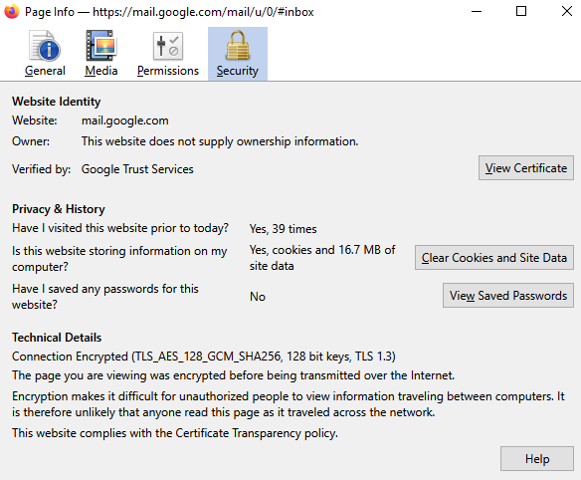
Step 05 : now you can see the certificate details

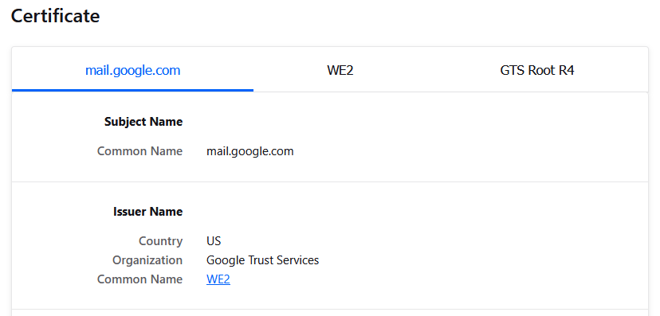

Browser certificate view:
Step 01 : open firefox browser and click settings icon
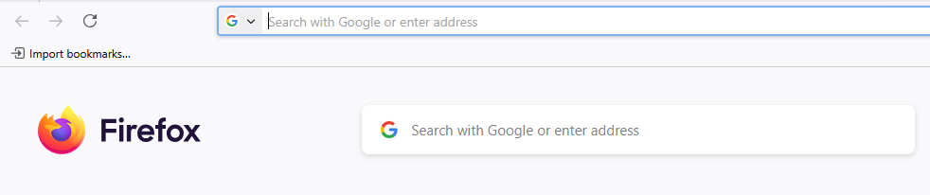
Step 02 : click manage more settings
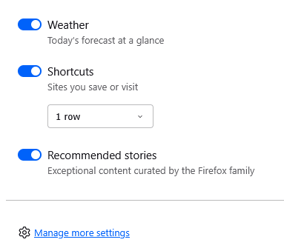
Step 03 : search certificates in search box
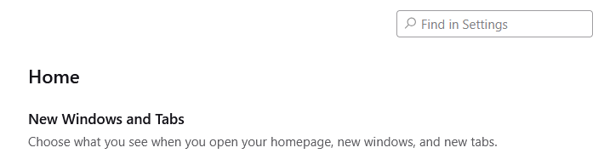
Step 04 : click view certificates
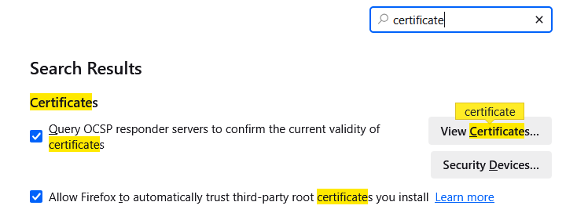
Step 05 : select any certificate and select view
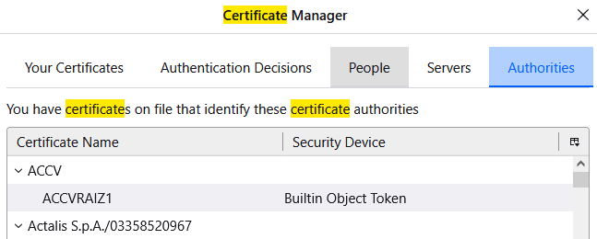
Step 06 : now you can see the certificate
